**WEEK 2 : CONTROL STRUCTURES**

**Exercise 3: Stored Procedures**

**Scenario 1: The bank needs to process monthly interest for all savings accounts.**

o**Question: Write a stored procedure ProcessMonthlyInterest that calculates and updates the balance of all savings accounts by applying an interest rate of 1% to the current balance.**

**CODE :**

CREATE OR REPLACE PROCEDURE ProcessMonthlyInterest AS

BEGIN

UPDATE savings_accounts

SET balance = balance + (balance * 0.01);

END;

EXEC ProcessMonthlyInterest;

SELECT * FROM savings_accounts;

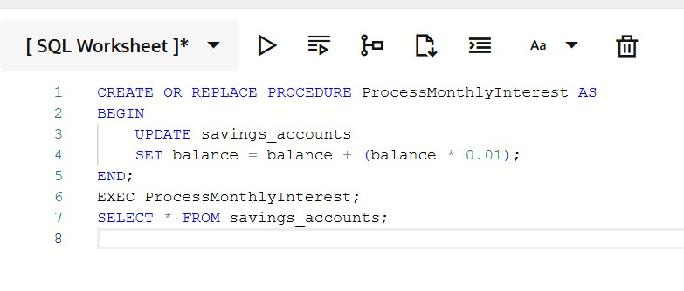

**OUTPUTS :**

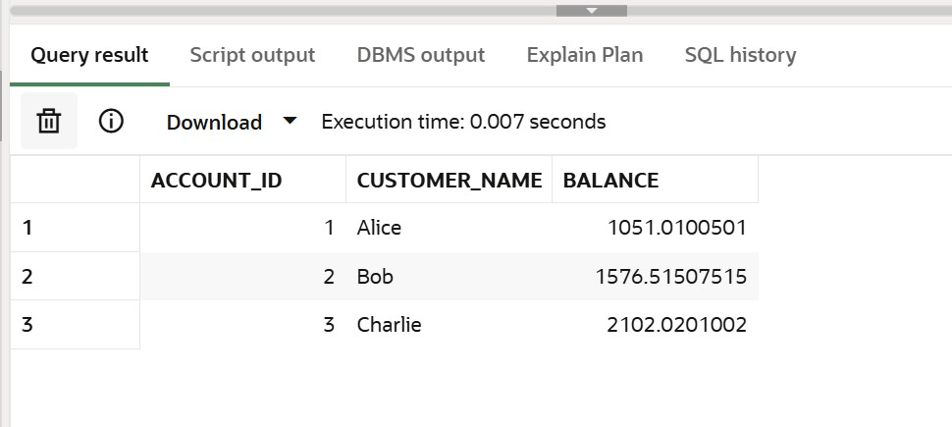

**Scenario 2: The bank wants to implement a bonus scheme for employees based on their performance.**

o**Question: Write a stored procedure UpdateEmployeeBonus that updates the salary of employees in a given department by adding a bonus percentage passed as a parameter.**

**CODE :**

CREATE OR REPLACE PROCEDURE UpdateEmployeeBonus ( dept IN VARCHAR2, bonus_percent IN NUMBER

) AS

BEGIN

UPDATE employees

SET salary = salary + (salary * bonus_percent / 100)

WHERE department = dept;

END;

EXEC UpdateEmployeeBonus('IT', 10);

SELECT * FROM employees;

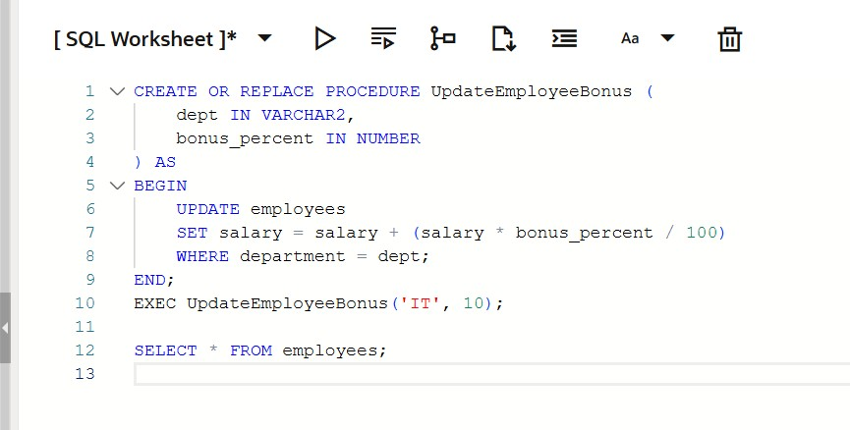

**OUTPUT :**

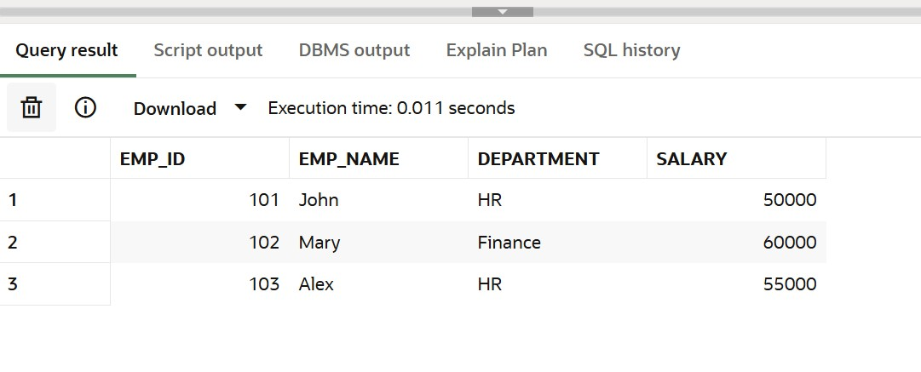

**Scenario 3: Customers should be able to transfer funds between their accounts.**

o**Question: Write a stored procedure TransferFunds that transfers a specified amount from one account to another, checking that the source account has sufficient balance before making the transfer.**

**CODE :**

CREATE OR REPLACE PROCEDURE TransferFunds ( from_account IN NUMBER,

to_account IN NUMBER, amount IN NUMBER

) AS

from_balance NUMBER;

BEGIN

SELECT balance INTO from_balance FROM bank_accounts WHERE account_id = from_account;

IF from_balance < amount THEN

DBMS_OUTPUT.PUT_LINE('Insufficient balance!');

ELSE

UPDATE bank_accounts

SET balance = balance - amount

WHERE account_id = from_account;

UPDATE bank_accounts

SET balance = balance + amount

WHERE account_id = to_account;

DBMS_OUTPUT.PUT_LINE('Transfer Successful');

END IF;

END;

EXEC TransferFunds(1, 2, 2000);

SELECT * FROM bank_accounts;

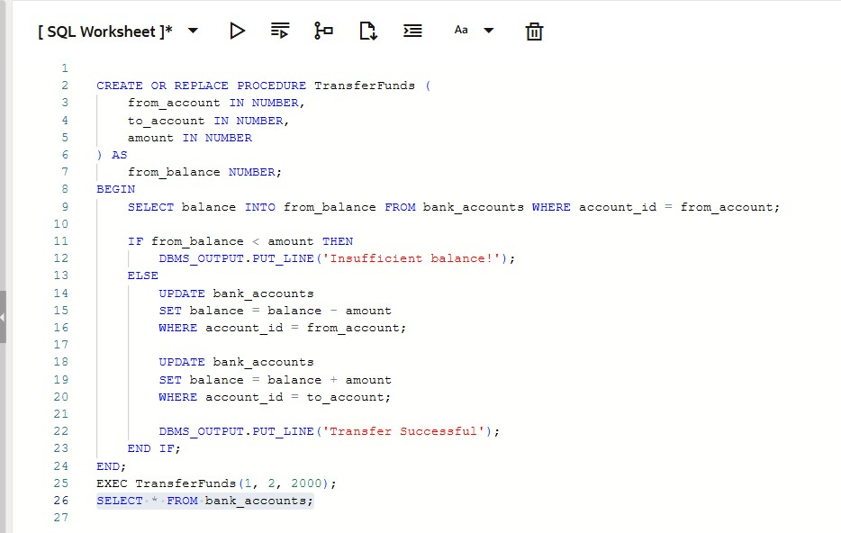

**OUTPUT:**

